**Experiment 01**

**Aim:**

To install and set up Burp Suite, Mutillidae, and Kali Linux for web application security testing.



**Tools:**

* **Burp Suite** – Web vulnerability scanner and proxy.

* **Mutillidae** – A deliberately vulnerable web application.

* **Kali Linux** – A Linux distribution for penetration testing and security auditing.



**Theory:**

* **Burp Suite** is an integrated platform used for testing web application security. It includes features like proxy, spider, scanner, intruder, repeater, and sequencer.
* **Mutillidae** is a free, open-source, deliberately vulnerable web application for learning and testing security tools.
* **Kali Linux** is a Debian-based distribution equipped with numerous tools for ethical hacking, penetration testing, and digital forensics.



**Steps for Installation and Setup:**

# Kali Linux Installation

* Download Kali Linux ISO from the official website:<https://www.kali.org/> ● Install using:

○ **VirtualBox/VMware** (recommended for beginners).

○ OR create a bootable USB and install directly on hardware.

* Follow on-screen instructions to complete the installation.

# Burp Suite Setup

* Burp Suite is pre-installed in Kali Linux. To launch:

Applications → Web Application Analysis → Burp Suite

* Configure the browser (Firefox/Chrome) to use proxy:

○ Proxy IP: 127.0.0.1

○ Proxy Port: 8080

* Import Burp's CA certificate into the browser for HTTPS interception.

# Mutillidae Installation

* Prerequisites: Apache, MySQL, PHP (pre-installed in Kali).

Clone the repository:

git clone https://github.com/webpwnized/mutillidae.git sudo mv mutillidae /var/www/html/

Start services:

sql

sudo service apache2 start sudo service mysql start

* Setup database:

○ Open browser and navigate to http://localhost/mutillidae

○ Click on "Setup/reset the DB" to initialize the database.

Burp Suite:

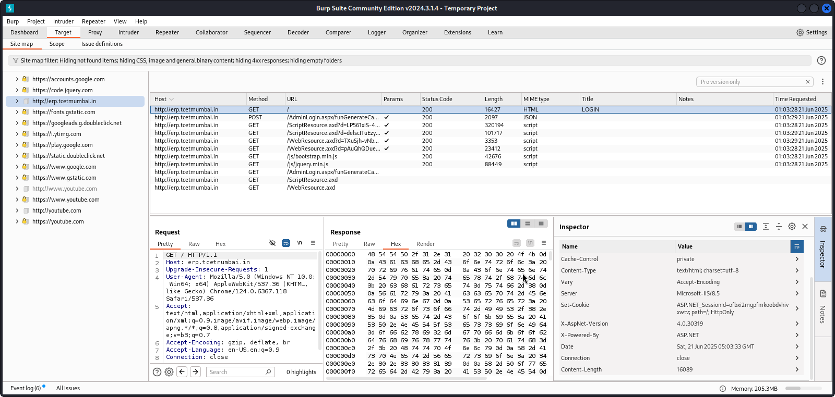

Mutillidae:  
  
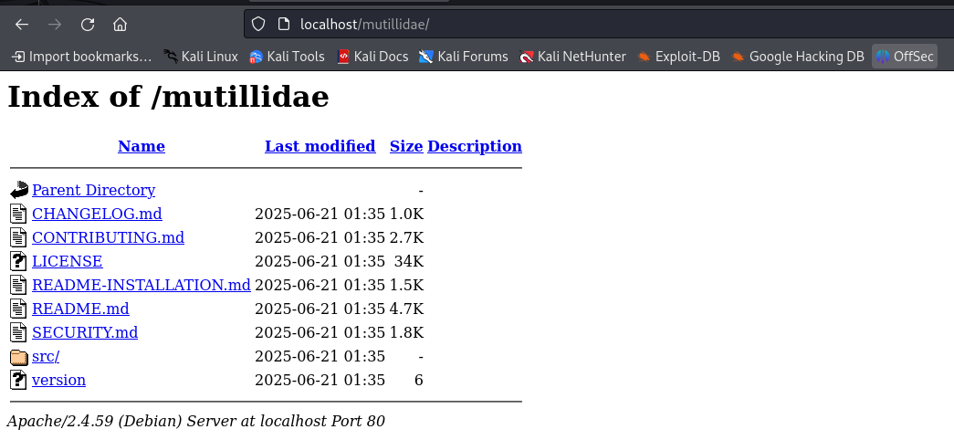

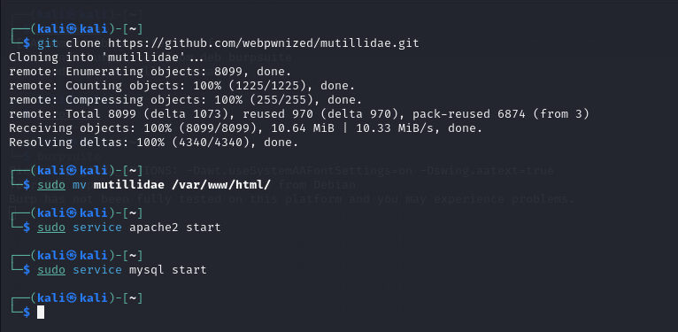

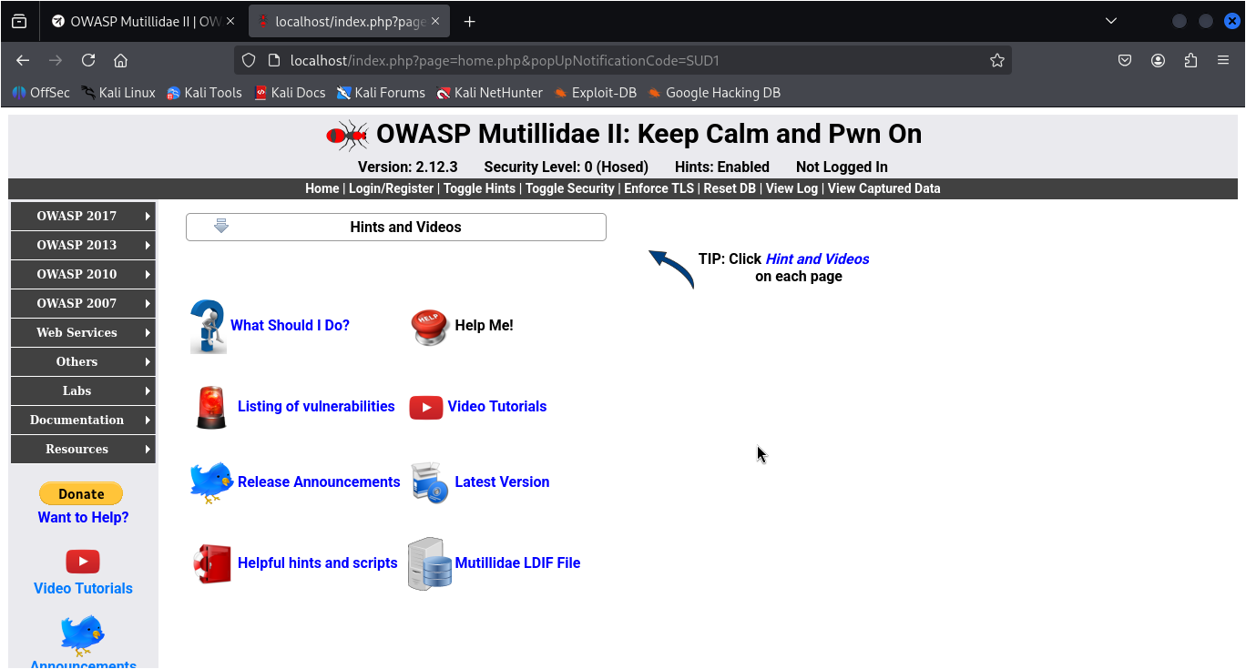

**Conclusion:**

The experiment provided hands-on experience with setting up a safe and controlled web application security testing environment using Kali Linux, Burp Suite, and Mutillidae.



**Theory Questions:**

1. What are the different modules provided by Burp Suite for testing web vulnerabilities?

1. Explain how a browser is configured to work with Burp Suite’s proxy.

1. What is the purpose of Mutillidae in web security testing?

**Learning Outcomes:**

**Outcomes:**

* Demonstrate the ability to successfully install and configure Burp Suite, Mutillidae, and Kali Linux to create a secure testing environment for web application security.
* Understand and apply the basic functionality of Burp Suite and Mutillidae in conjunction with Kali Linux tools to perform vulnerability assessments and exploit web application security flaws.

**Conclusion:**

**Name :   
Class: BE CSE  
Roll no:**

For Faculty Use:

|  |  |  |  |  |
| --- | --- | --- | --- | --- |
| **Correction**  **Parameters** | **Formative**  **Assessment**  **[40%]** | **Timely completion of Practical [40%]** | **Attendance /**  **Learning Attitude**  **[20%]** |  |
| **Marks**  **Obtained** |  |  |  |